**Cloud Computing: UE20CS352**

**Assignment - 1**

**Introduction to AWS Lambda with API Gateway**

**Name : Sanmat Sanjayakumar Payagoudar**

**Section : G**

**SRN : PES1UG20CS385**

# 1a: Lambda Function Created

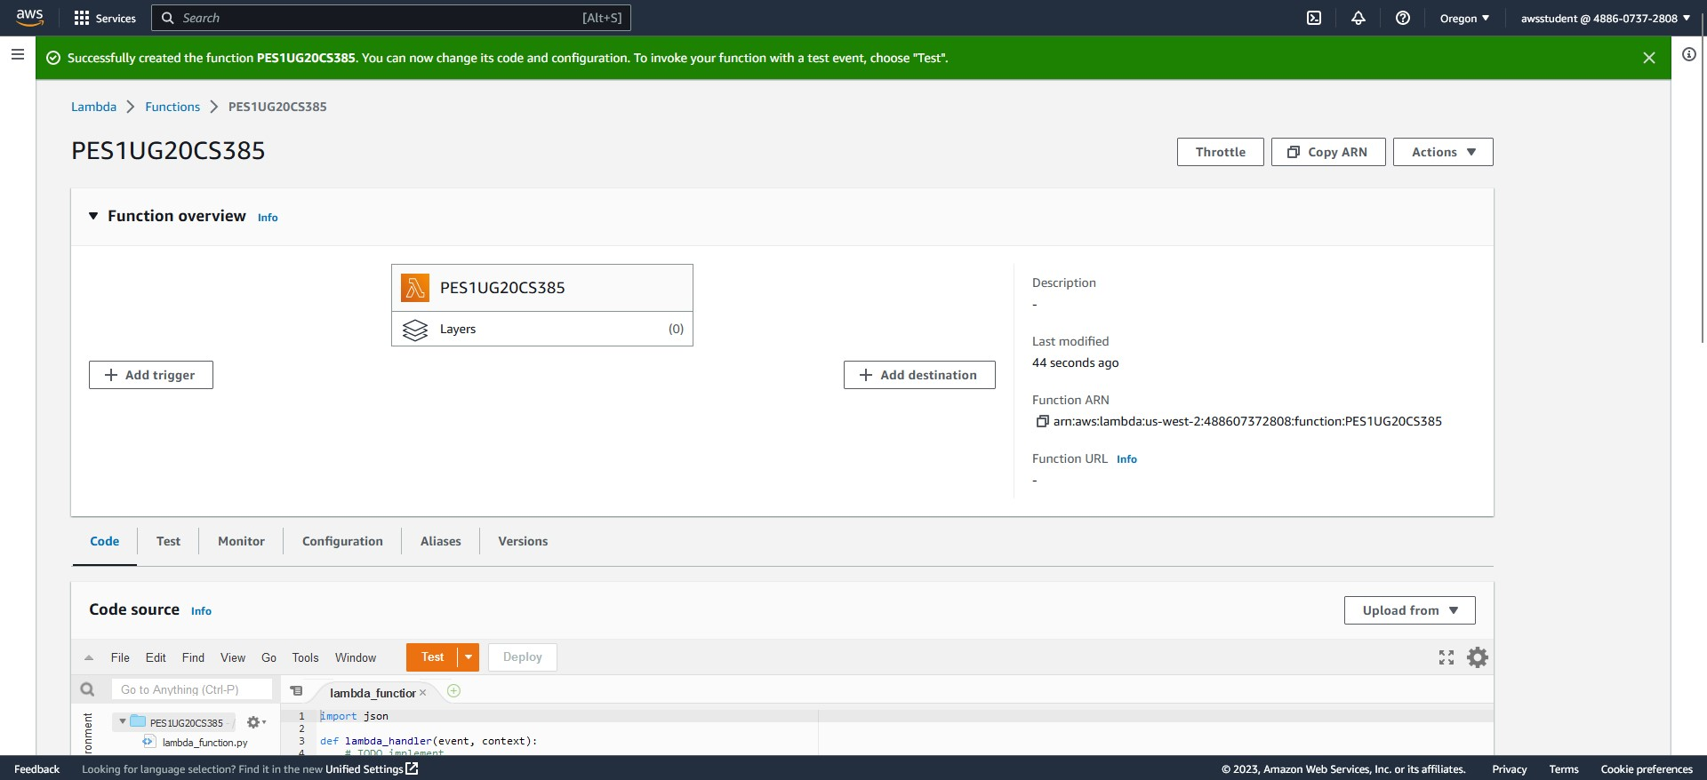

# 1b: API Gateway created, trigger added

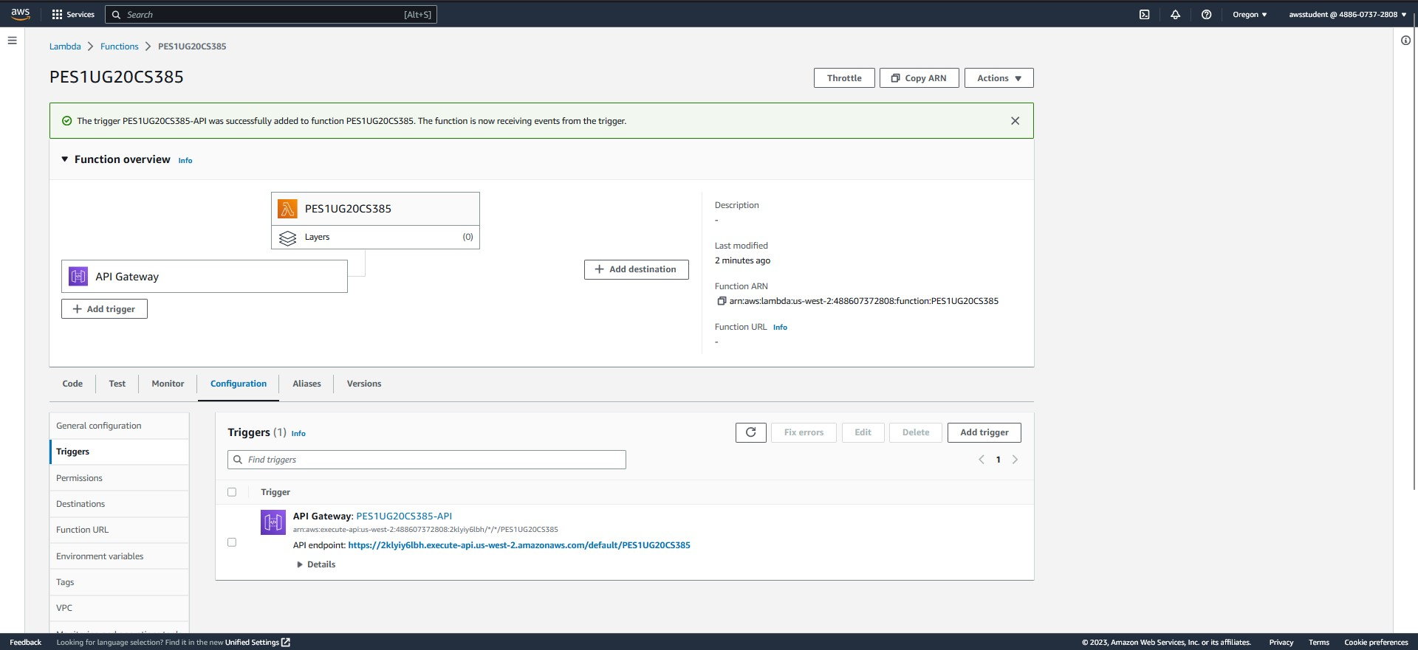

# 1c: Modified Lambda function

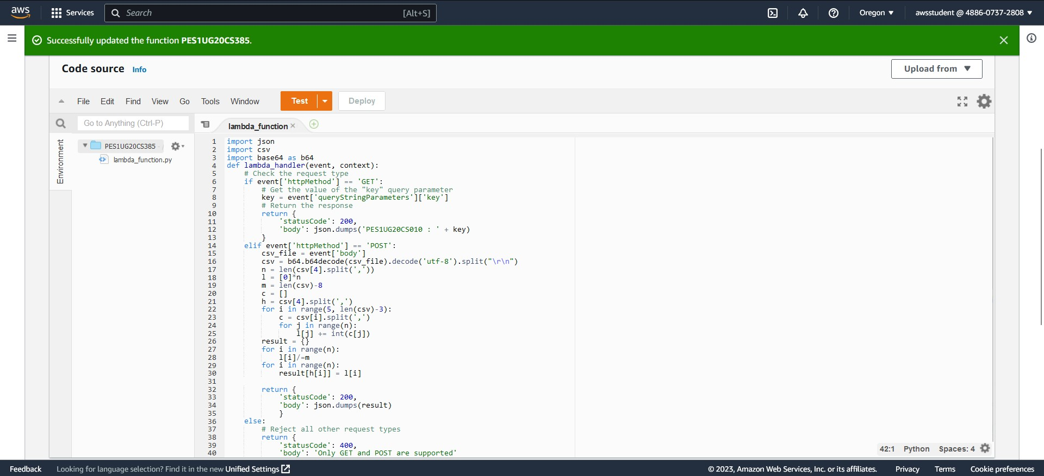

# 1d: Successful Postman GET request

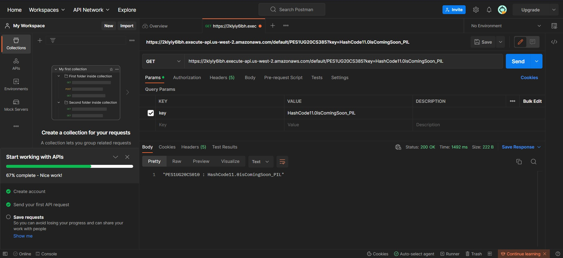

1e: Successful Postman POST request

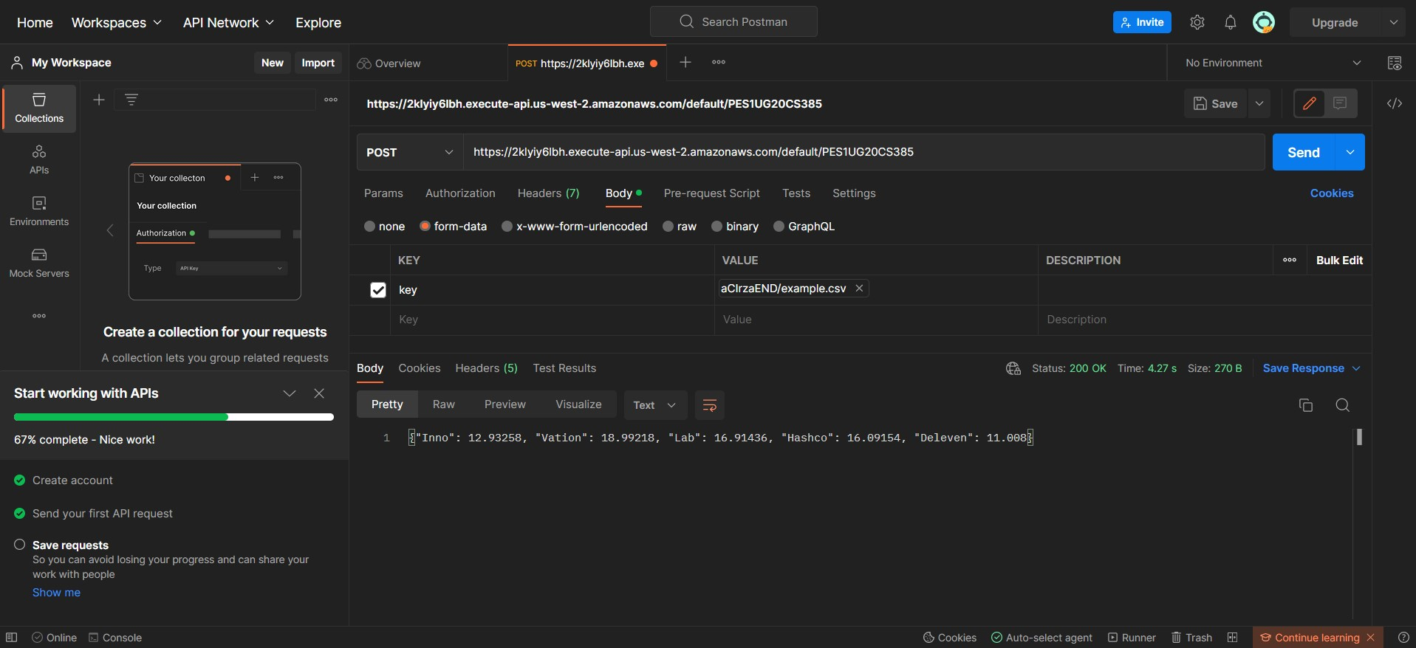

# 1f: Failed Postman PUT/DELETE/HEAD request

